# Angular Modules and Routing Exercises

## Create Home Page

Create a home page, upon which you have the ability to choose between four factions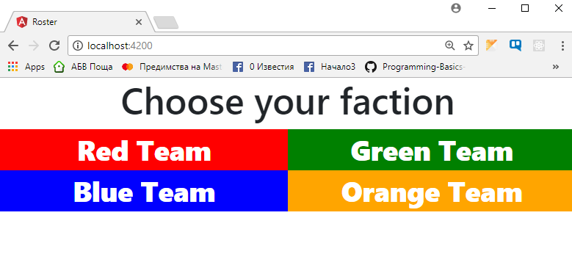

## List the articles

Upon login you should be redirected to a page, through which you should be able to attack a fraction, or logout.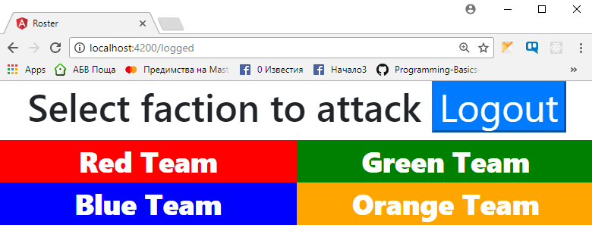

After successfully choosing a fraction, before pressing the 'Logout' button or clearing your session, you must be always redirected to the '/logged' page when trying to reach the '/' page

## Attack the enemy

Upon attacking the enemy factions, you should pass, the name of the enemy you are attacking through a query string.

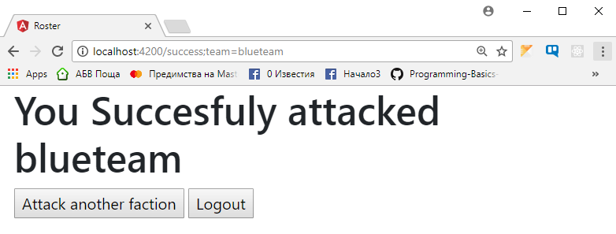

## Attack Yourself

Upon attacking your own faction, you should display an error message, similar to the one below.

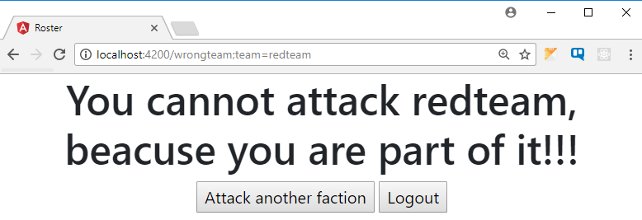

! HINT: for task 3 and 4, its recommended to use route guadrs, for task 2 its recommended to use 'LazyLoading'